Honorary Secretary  Nicholas Baldwin, Archivist,  Great Ormond Street Hospital for Children  London WC1N 3JH  Email: nick.baldwin@gosh.nhs.uk  Tel: 020 7405 9200 x 5920 | 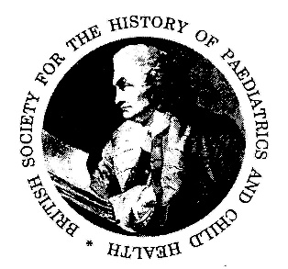 | President  Professor Michael Dillon  michael.dillon@ucl.ac.uk

BRITISH SOCIETY for the HISTORY of PAEDIATRICS and CHILD HEALTH
www.BSHPCH.com

AUTUMN MEETING, 2022
At the Royal College of Anaesthetists, London

Friday 16th and Saturday 17th September 2022

Registration form and Call for Abstracts (Members)

Abstracts Papers (25 min) for Presentation
Please submit abstracts of papers for consideration for presentation (250 words, including title of paper, name and address of author) to the President (michael.dillon@ucl.ac.uk) by e-mail by 1st August 2022.

Registration – for members of the BSHPCH
Please register promptly to secure accommodation (see note below).
Full Package = Registration, bed for Friday night, dinner and wine reception, 2 lunches (Breakfast not included).

Full Package cost both days, lunches, dinner and accommodation Friday night £ 224
Day Delegates – both days, 2 lunches, dinner, but no accommodation £ 175
Day Delegates – both days, 2 lunches, no dinner or accommodation £ 100
Dinner and wine reception only - £ 75
Accompanying persons; lunch Friday £15, dinner + wine reception £75; lunch Saturday £15.

Day Delegate Students – lunches, tea and coffee £ 25
the above + dinner £ 90
Accommodation
We have reserved 12 rooms at the Premier Inn, Holborn, at a cost of £49 per double room. These have to be released if not booked a month before the meeting. This Premier Inn is within walking distance of the conference and the dinner venue (Royal College of Anaesthetists at 35 Red Lion Square). These rooms can obviously be used as single or double at the price we have been offered.

Please print name and address below, circle requirement, cheque payable to ‘BSHPCH’ and send by mail with this form by 1st August to:
Dr J Dossetor, 63 Castle Rising Road, South Wootton. Kings Lynn, PE30 3JA
01553 674022 E-mail jonathan.dossetor@btinternet.com

Alternatively form back by e-mail, and payment by BACS to Natwest bank; account number 60715499; sort code 56-00-34. Account name ‘British Society’. Reference – your surname + london22

Name: …………………………………… Accompanying person…………………………...

Address: ……………………………………………………………

………………………………………………………………

.Email: ………………………………………………… Phone:…………………………

Special dietary requirement…………………………

